Sprint Retrospective Notes

SEPT Team 03  
**Sprint 02**  
Date: 18SEP201  
  
**Attended**  
Scrum Master: Roman O’Brien  
Product Owner:   
Development team: David Morrin, Charlton Ho, Allen Muthupunnackal Jose  
  
**Things That Went Well**  
*What went well? What is the team happy about?*

* Finished the majority of the functionality, which is a big step up from last sprint (where were not able to finish a user story!)
* Happy that our Continuous Integration system is working and properly generating docker builds.
* Set more feasible goals during planning, allowing us to thoroughly complete the goals we did set.
* Happy that I (Roman) understand most of the JWT security/authentication now, after days of research and experimenting with the code
* Team had good communication, with regular daily meetings and quick responses in slack.

**Things That Could Have Gone Better**  
*What could have gone better? What could the team improve?*

* Two of our team members had adverse reacts to a COVID vaccine dose right in the last days of our Sprint – a bit stressful and slowed our progress a little as they rested.
* None of the features were completed until the last day of the sprint – perhaps given better learning resources or by having multiple people work on the same features we could finish them faster and move in an iterative fashion.

**Things That Surprised Us**  
*What wasn’t expected?*

* No webinar for testing yet – made it difficult to discover and learn independently – some tests are still not written as a consequence.
* The Spring Security implementation took a while to learn and understand – felt quite complicated for beginners to work with.

**Lessons Learnt**  
*What have we learnt from the points above?*

* If you don’t understand how to accomplish a task, the research will take a lot longer than implementation – and longer than you expect.
  + So start early!

**Final Thoughts**  
*Things to keep. Things to change.*

* Continue to have daily scrum meetings where members talk about their accomplishments that day – helps to keep everyone informed and gives a sense of accountability so work continues to be done.
* We’re building experience quickly and are now better able to judge our abilities and time – next sprint should be easier and more productive.

**Burndown Chart**

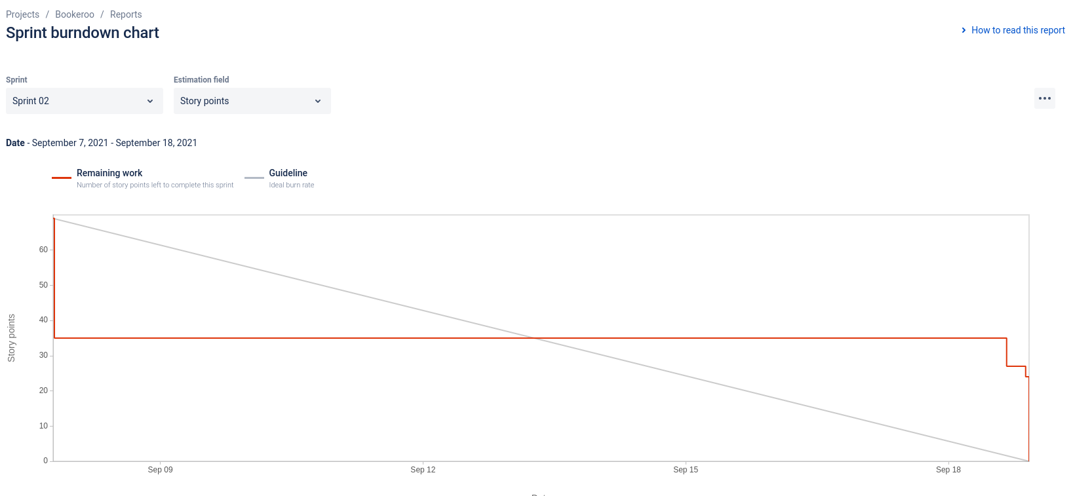

**Sprint Velocity Chart**

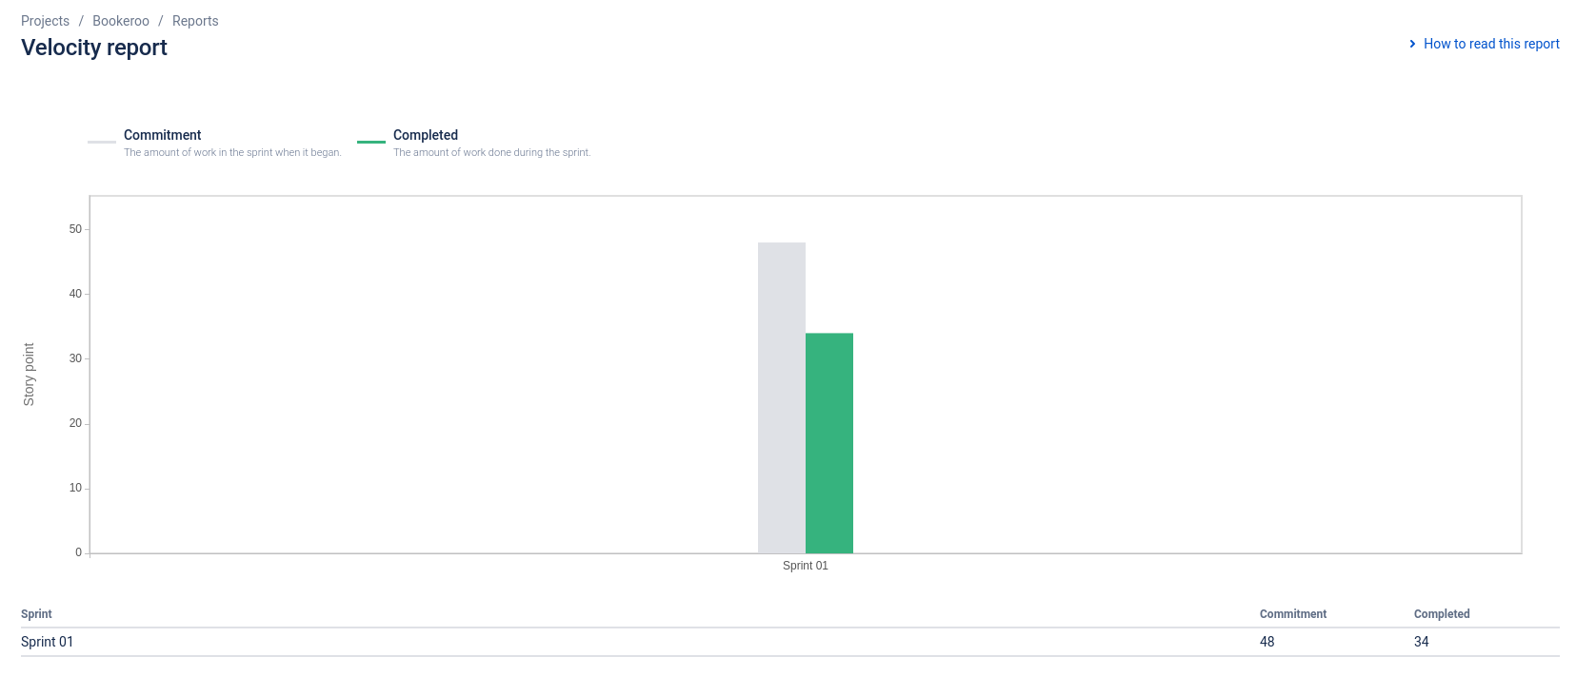

**Cumulative Flow Diagram**

